

**ADVANCED APPLICATIONS DEVELOPMENT USING JAVA**

**GROUP PROJECT: PARKING SLOT MANAGEMENT**

**By**

**Sahith Manchi (700742554)**

**Priyanka Mula (700741307)**

**Vismitha Muchu (700742558)**

**INTRODUCTION:**

We have created an application for Parking Slot Management. The goal of our project is adding the parking slots, booking the added slots and managing the booked parking slots like editing the slot which is booked previously or deleting the slots. The application has a text-based user interface and has buttons like Add Slot, Book Slot and Manage slot. It updates records, adds new records, and removing existing entries. This program simply requires the user to input the corresponding value or text of their desired choice, which will then be recorded within the system.

We followed Spring MVC framework and microservices architecture for building the application.

**Tools used for the project**: Eclipse and MySQL

**Programming language**: Advanced Java

**ARCHITECTURE:**

ADD PARKING SLOT

USER

 SPRING MVCS

& SPRING DATA JPA

j

BOOK SLOT

 Database

GUI

MANAGE SLOTS

**START THE APPLICATION:**

1. Run both the projects on spring boot app or just run the main classes as run as Java application.
2. Now make sure you are giving same schema name of your MySql application in application.properties file for both apis.
3. Once your both APIs are up, then use the below URL to get on to the Home Page.

<http://localhost:8090/booking-service/homePage>

1. Now you can go through the application make use of it. I have mentioned the application functionality below for reference.

**DESCRIPTION:**

We have implemented the below CRUD operations in our Parking slot management Java application:

1. Adding a parking slot
2. Booking the added parking slot
3. Manage the slots (Edit & Delete)

**CODE STRUCTURE AND FEATURES:**

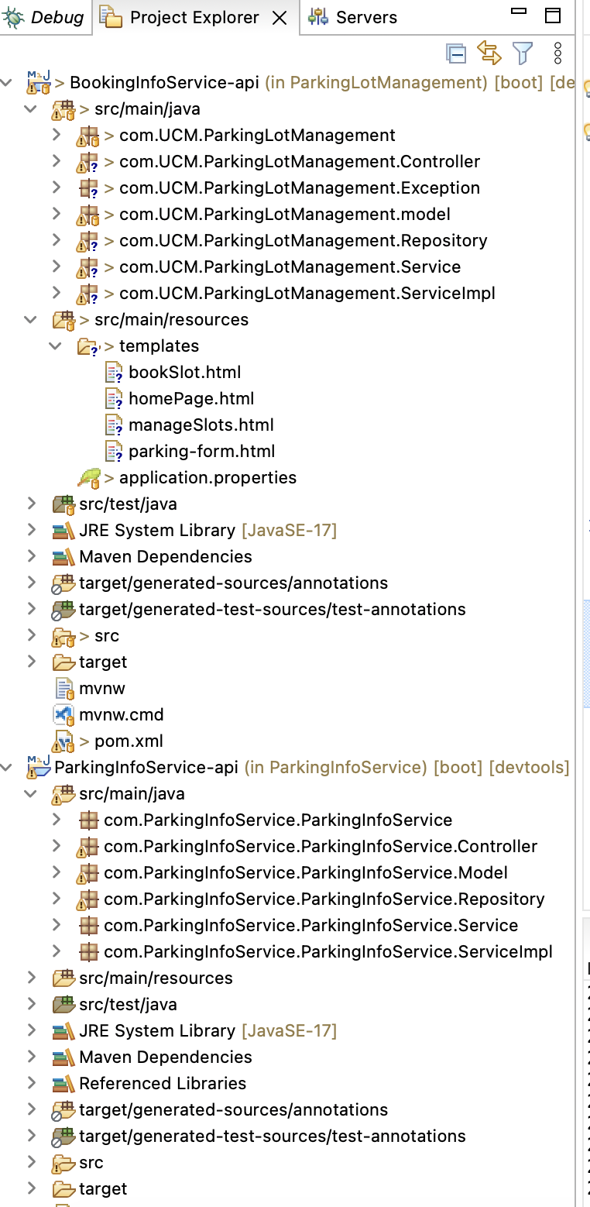

This Project Structure Consists of 2 micro services:

1. ParkingInfoService api
2. BookinginfoService api

This Project also consists of 2 Databases:

1. parkinLotDetails
2. bookingInfoSchema

**CONTROL FLOW:**

DATABASE

SERVICE  
& ENTITY

CONTROLLER

REPOSITORY

USER REQUEST HTML & THYMELEAF

**USER REQUEST OR FRONT END:**

1. we are using HTML and thymeleaf to develop and maintain all the front-end related interface and experience.
2. HTML files consists of <style></style> tags where we set up all the form related and button related designs.
3. HTML file also consists of thymeleaf which is a view resolver feature. In this we can parse model or objects to corresponding HTML files and map the object entities to the fields for adding or getting the data.
4. Thymeleaf is a popular server-side Java template engine that is often used in Spring projects. It allows developers to easily create dynamic HTML pages using natural templates, enabling faster development times and more maintainable code.

Thymeleaf import statement: *<html xmlns:th="http://www.thymeleaf.org">* this will bring all the thymeleaf templates to your html page and make it dynamic.

Our Add Parking Form page code for reference of this front end:

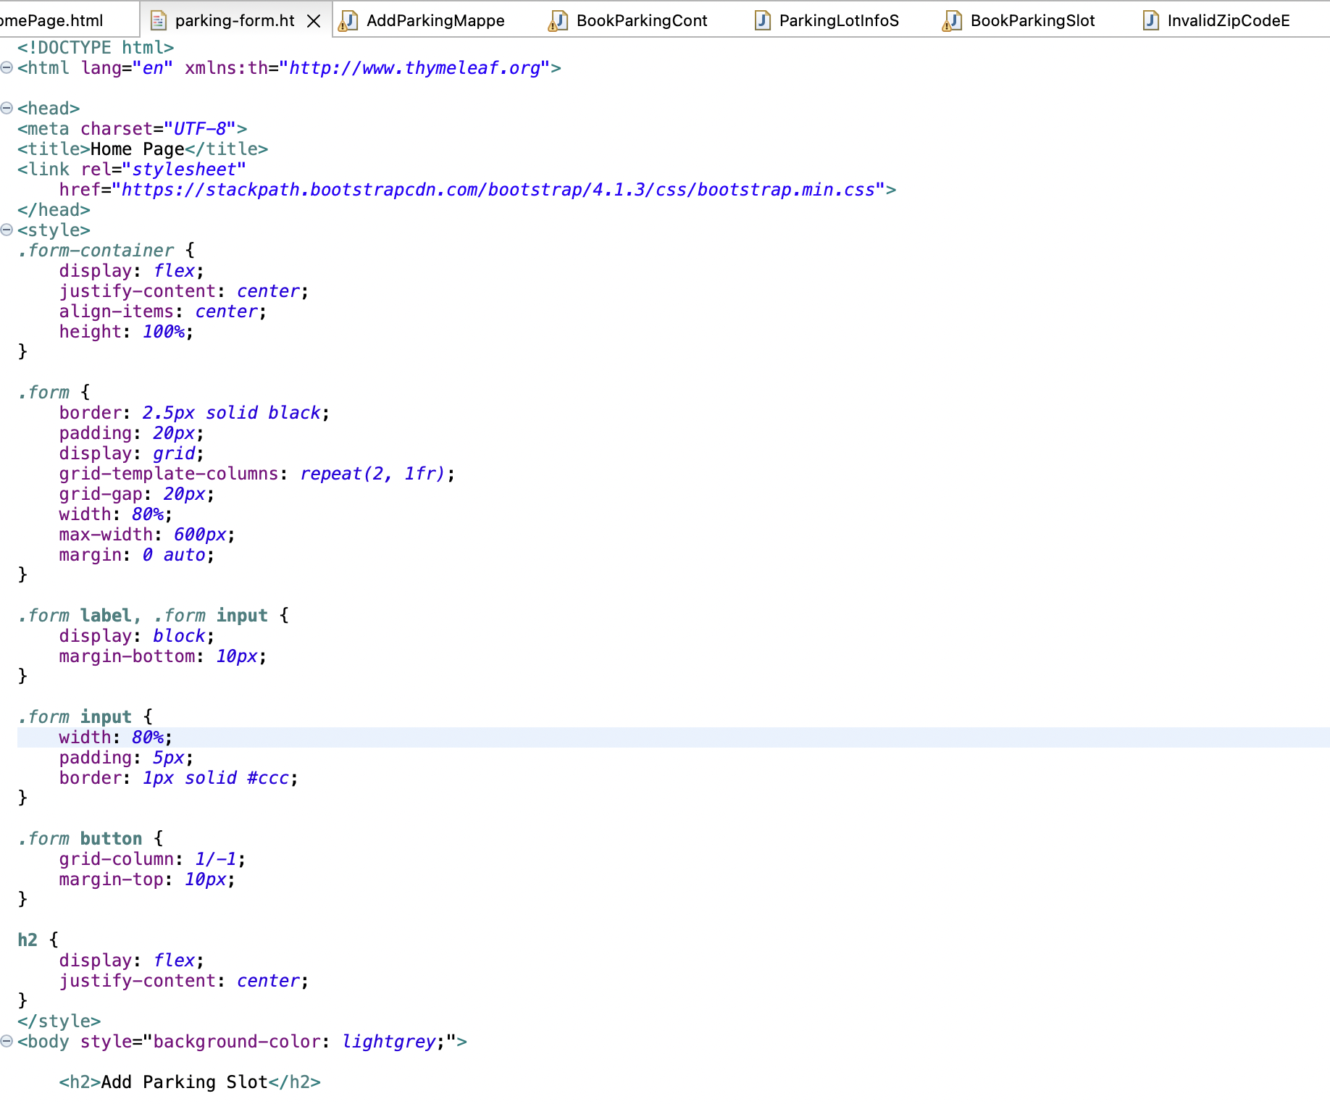

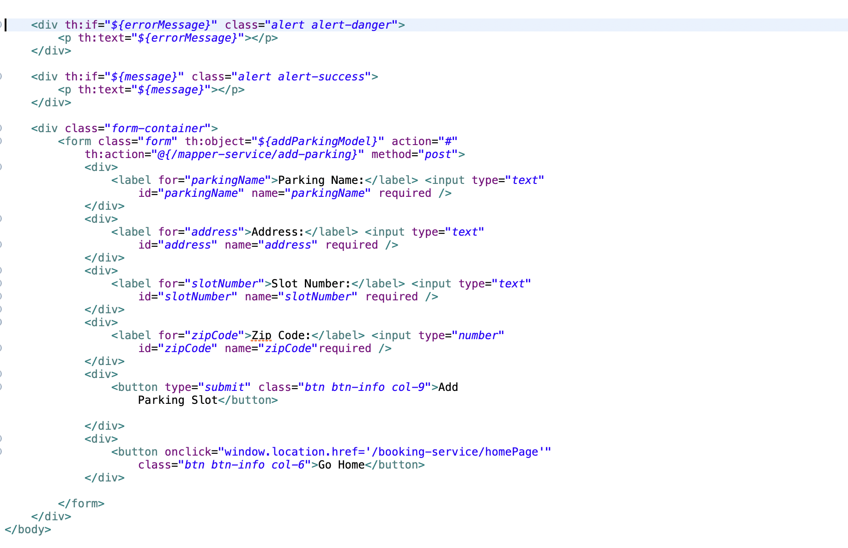

**Controller:**

1. All the controller classes will accept the requests which are being sent by the front-end. Controller consists of all the API’s related to GET, POST, PUT, DELETE.
2. Controller class is responsible to send the responses back to HTML file to bind or render the data.
3. Since we are following a model-view based architecture our response bodies will capable to handle the object using THYMELEAF Template.
4. Thymeleaf has most of the feature where it can work like JavaScript. Which means it can work as object mapper, iterating over the object to set up values.

Controller Class in Project:

1. ParkingInfoService api
2. AddParkingController.java
3. BookingInfoService api
4. BookParkingController.java
5. AddParkingMapperController.java

**Service & Entity Classes:**

1. All the service-related implementation is followed by encrypting the implementation since we are using interfaces and service implementations for those interfaces.
2. We maintained the Entity classes to map relational database tables to Java objects. These classes contain attributes that represent the columns of the database tables and define the relationships between tables. By using entity classes, developers can easily perform CRUD (Create, Read, Update, Delete) operations on the database using object-oriented programming techniques instead of writing SQL queries. Entity classes are typically annotated with JPA (Java Persistence API) annotations to provide the necessary metadata for mapping the objects to the database.

Service Classes:

1. ParkingInfoService api:
2. **interface** ParkingLotInfoService.
3. **class** ParkingLotInfoServiceImpl **implements** ParkingLotInfoService.
4. BookingInfoService api:
5. **interface** BookParkingSlotService.
6. **class** BookParkingSlotServiceImpl **implements** BookParkingSlotService.

Entity class:

1. ParkingInfoService api:
2. ParkingLotModel.
3. BookingInfoService api:
4. BookParkingSlotModel.
5. ParkingLotMapper.

**Repository:**

1. We used Spring Data JPA for all the database related operations.
2. We have added the spring data jpa dependency to get the features of JPA to our project.
3. Spring Data JPA makes it easier and more efficient to interact with databases in Spring projects, reducing development time and improving code quality.

**Database:**

1. We used MySql as our database to maintain all the records of our data related information. We have created scheme by using hibernate’s auto DDL function.
2. We have created tables by default from entity classes.

* Bookinginfoschema
* Parkinglotdetails

**MICRO SERVICE IN THIS PROJECT**

This is the Microservice-based architecture. This project follows synchronous communication. Microservice synchronous communication refers to a communication pattern between microservices where the caller waits for the response from the called microservice before continuing its processing. It is typically achieved through REST API calls or RPC (Remote Procedure Calls) and can be useful for scenarios where the response from the called microservice is necessary for further processing by the caller. However, this can lead to potential performance issues, especially when multiple synchronous calls are involved, and can be less resilient to failures.

**WE USED REST TEMPLATE FOR OUR PROJECT**

RestTemplate is a popular class in Spring Framework that simplifies the process of making HTTP requests to a RESTful web service. It is a useful tool for implementing microservice communication and integrating with external APIs. We used a modelMapper to send data taken from one microservice to another.

Code example where post the data taken from one microservice to another:

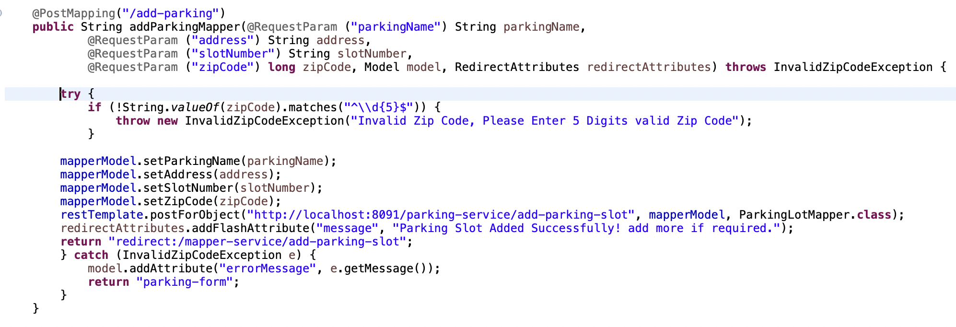

This is one place where used rest template to send date to another,

likewise, we used to get the list of slots from parking info api to booking info api. In which we used *restTemplate.getForEntity(url, entity.class).* the code used in the controller to get the data from another entity is implemented like the below.

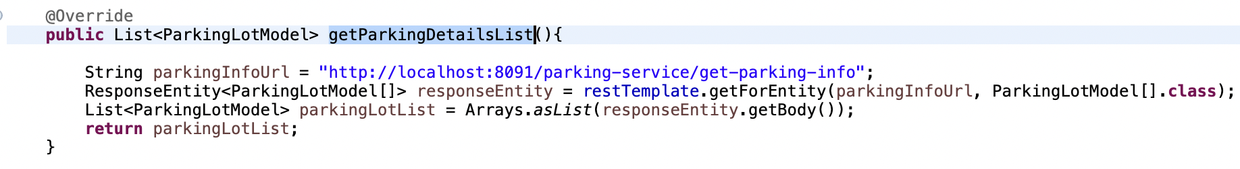

**FUNCTIONALITY:**

This is our HOME PAGE of Parking Lot Management System

It consists of 3 buttons:

1. Add Parking Slot
2. Book A Parking Slot
3. Manage Slots

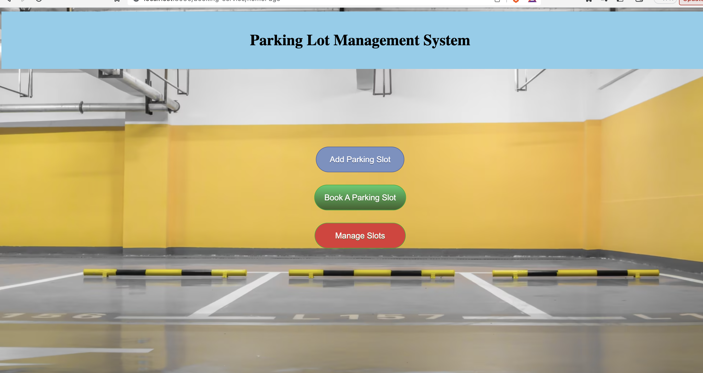

**1st Button – Add Parking Slot:**

Fields involved in Add Parking Slot form are

1. Parking name
2. Address
3. Slot number
4. Zip code. (This fields has validation)

Add Parking Form looks like this:

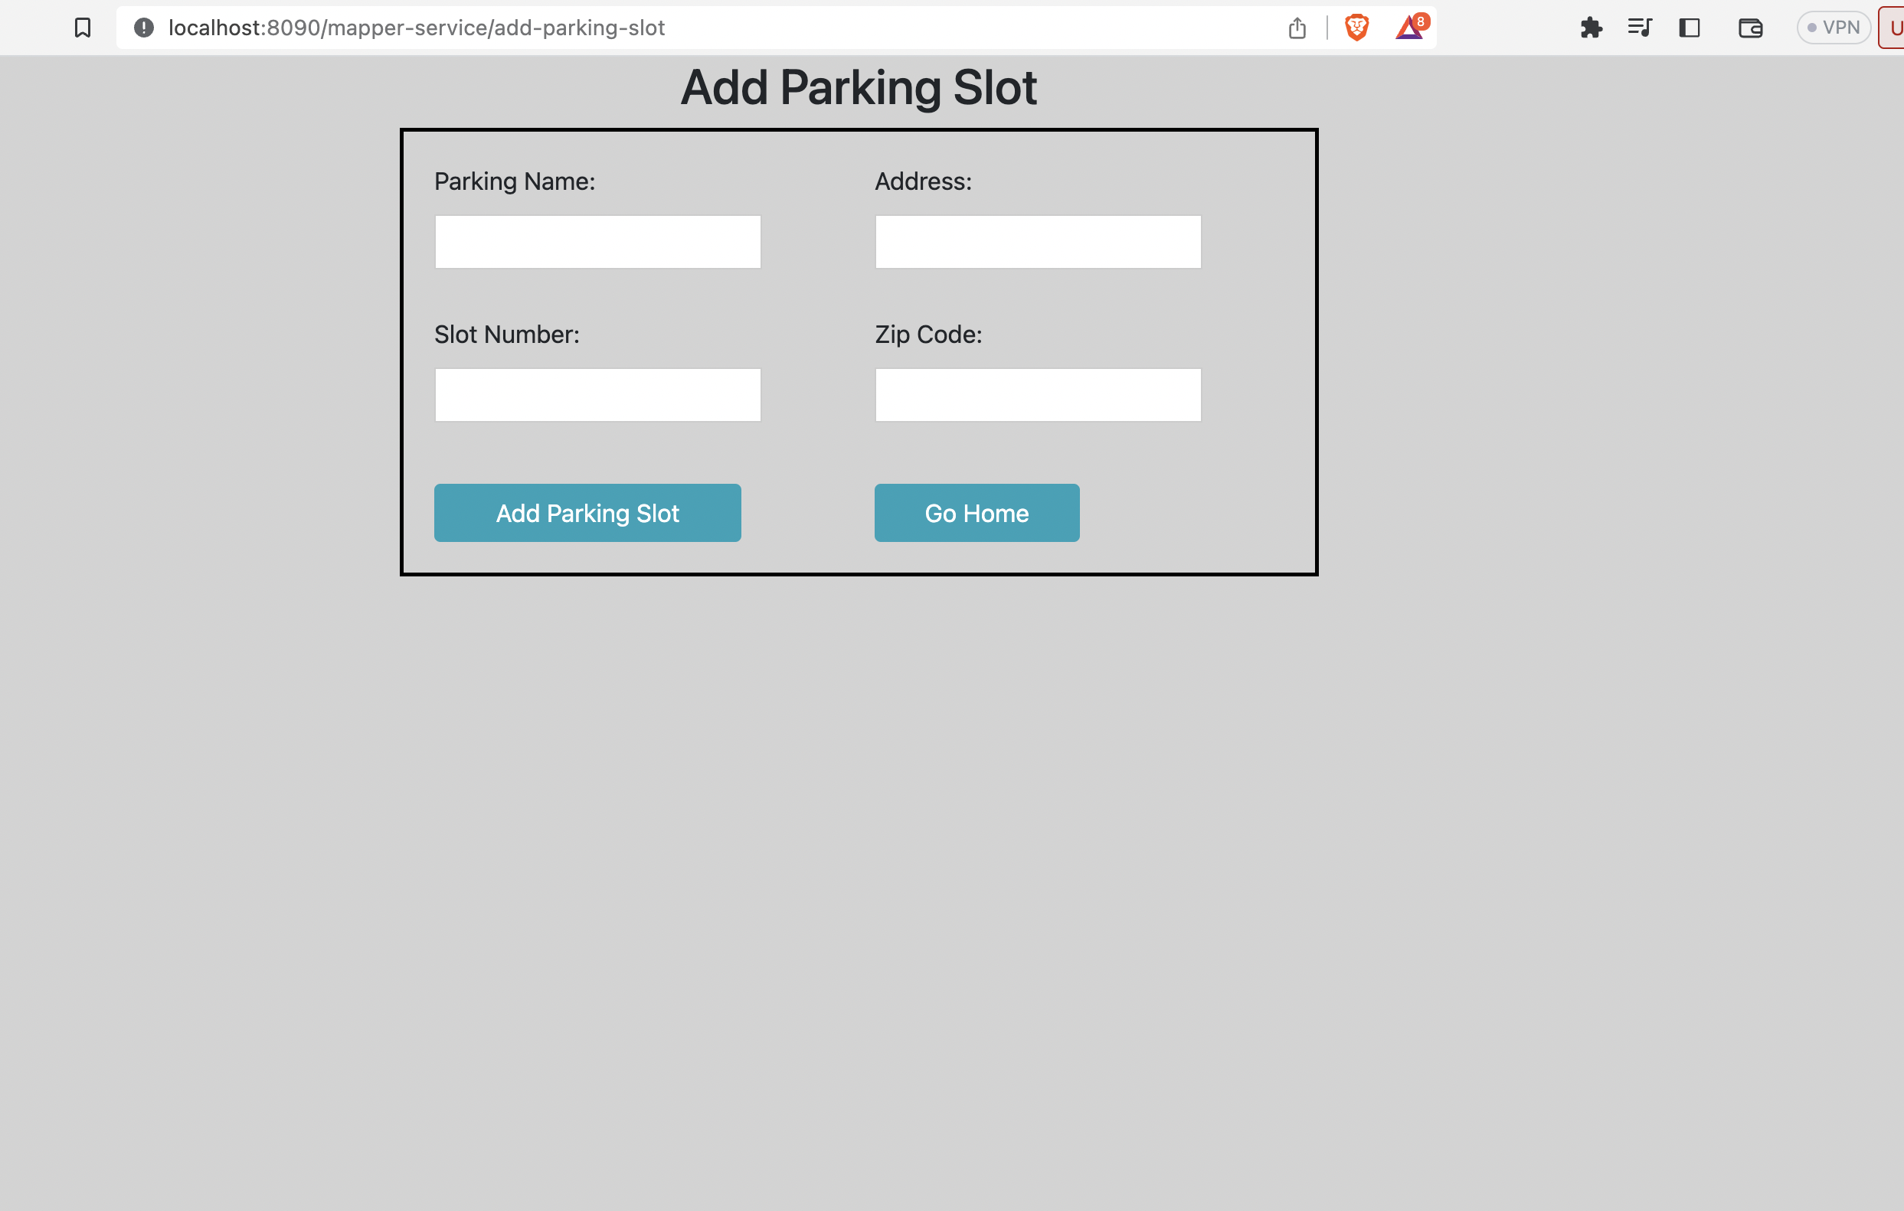

**Validation:** we added a validation on zip code, if you try to enter more than an invalid zip code it will throw an error ‘Invalid Zip Code, Please Enter 5 Digits valid Zip Code’. We used custom exception for this validation.

Our custom Exception class:

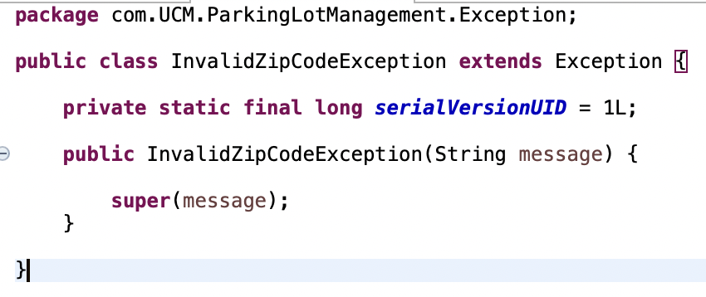

Code for our Validation:

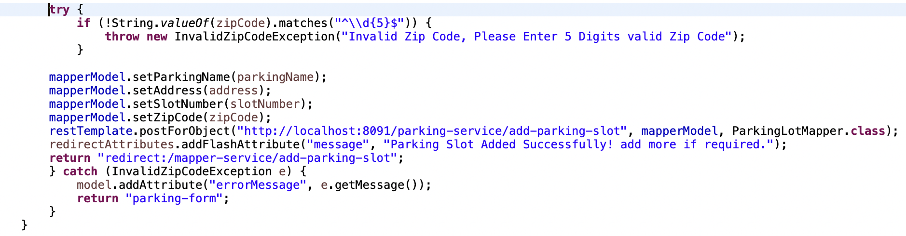  
  
**2nd Button – Book A Slot Form:**

Fields involved in this form:

1. First Name:
2. Last Name:
3. Phone Number: (This will perform Validation)
4. Vehicle Number:
5. Start Date: (This will perform Validation)
6. Start Time: (This will perform Validation)
7. End Date:
8. End Time:
9. Select a parking lot:

once user clicks the book a slot button it will redirect to a form where user need to give all the personal and vehicle related information and start data, start time along with end date and end time. There user can see a drop down of available parking slots which user need to select one from drop down and submit the form. You can redirect to home by click go home button.

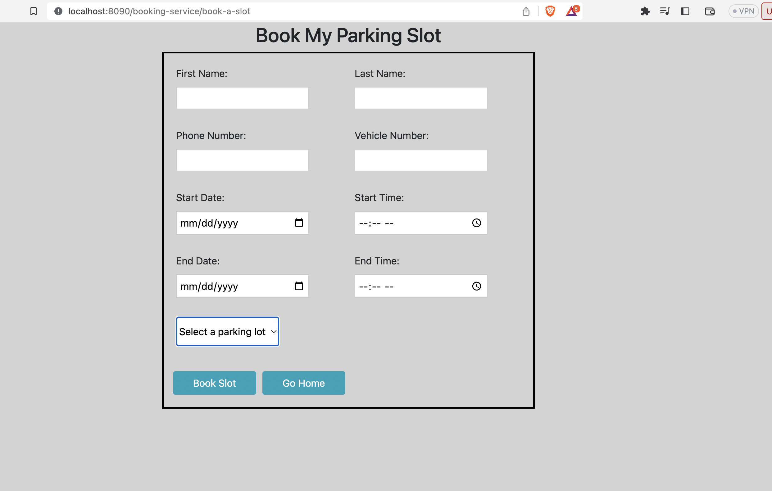

**Validations performed on this form are:**

1. Phone number: if user tried to enter any number which is over 10 digits, then it will throw an error ‘Phone number is Invalid, Enter a valid phone Number’. For this we used the **RedirectAttributes** interface in which you will have **redirectAttributes.addFlashAttribute(String, String);** method. This method will give an error message to HTML page and thymeleaf will capture the error and display our error message on web page.
2. Similarly, we validated the dates as well, like if user tried to set the end date before the start date or end time before the start time on same date. It will through the error message on display. ‘End Date must be after the start date!’.

Code for those validation is:

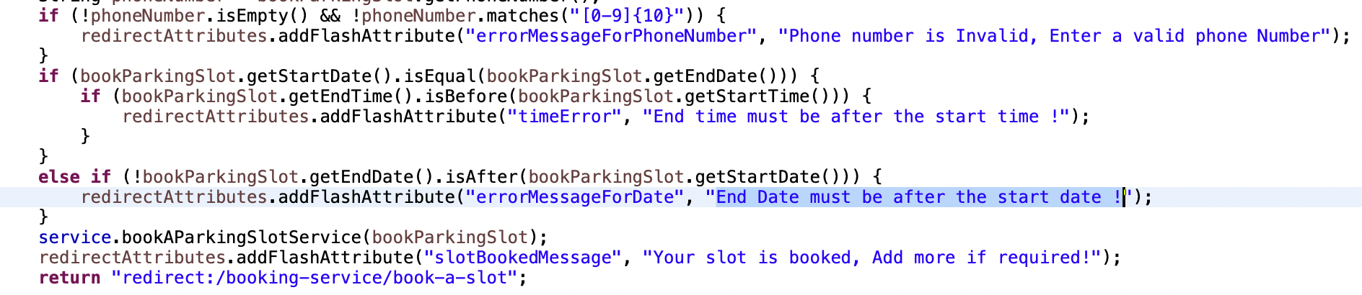

Validations on display looks like this:

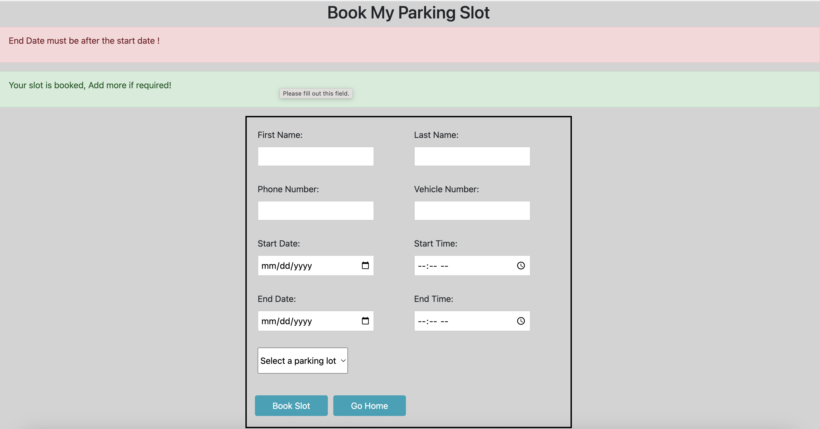

# **3rd Button: Manage Slots:**

# This page is used to retrieve all the slots information with edit and delete options on each row to update and delete the slot. You can update the existing slot and can delete the slot. This form consists of both slot details and parking details.

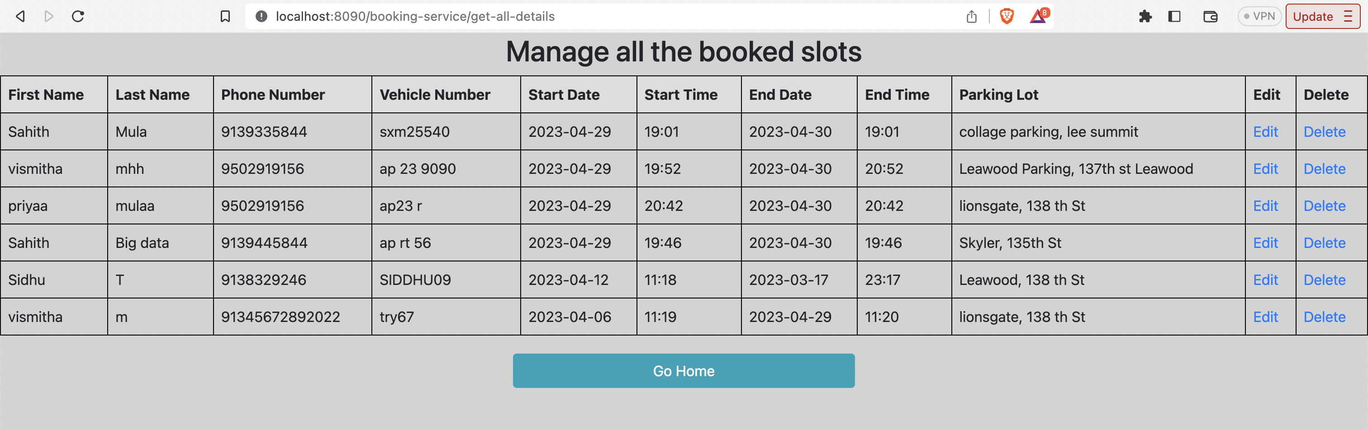

All the above operations are updated in database tables:

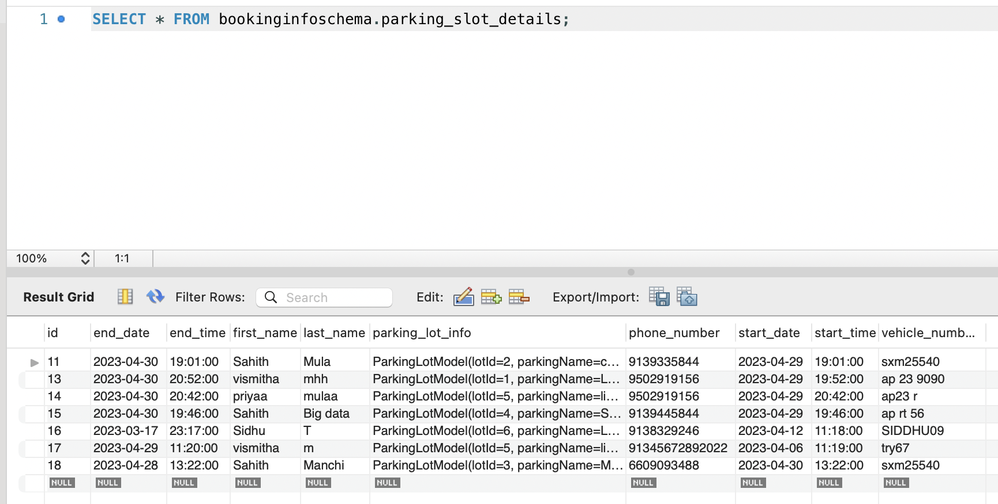

You can see the same Manage slots table details in database. This is where we performed the READ operations to read all data from database.

CONCLUSION:

This is a semi level business application where it managed to have micro service architecture, standard RDBMS with proper validations and easy user interface.

--------------------------------------------------THANK YOU-------------------------------------------------